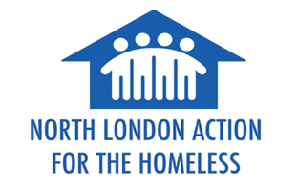

Volunteer Registration Form

Name |  | Date
Address
Borough
Phone
Email

Why are you interested in volunteering at North London Action for the Homeless?

[100-200 words max]

Please give details about any previous volunteering you have done before.

[100-200 words max]

Volunteering Commitment
NLAH is open twice a week, with 2-3 hour volunteering shifts on both days. Please replace the check box with an X on the day(s) you are usually available:

Mondays: between 8.30am-3.30 pm
Wednesdays: between 4.00pm-9.00 pm

If you decide to volunteer with NLAH (after your induction), would you be able to give a minimum commitment of 2-3 shifts per month for 3 months? Yes / No [delete one option]

Volunteering Roles
Our current volunteering roles vary between helping with behind the scenes work (e.g. kitchen prep, washing up etc) or front of house work (e.g. serving food and creating a welcoming environment for our guests). We have roles to suit pretty much anyone, so just let us know what kind of work suits you best.

[100-200 words max]

At NLAH, we thrive in having people of different backgrounds, age, genders, abilities and try to make the space as welcoming and inclusive as possible. Our hall is fully accessible and the volunteering roles are varied.
If you have any extra support needs, you can give details in the box below or discuss further via email / in person.

sdf

